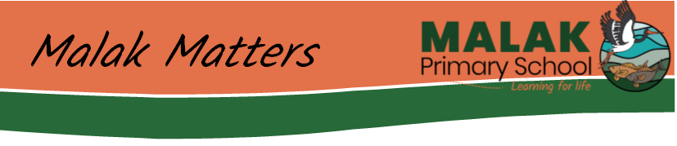
Term 1 Week 10 –09/04/2021
Mayilema- Speargrass,goose, egg and knock ‘em down season

Dear Families,
I am shaking my head in disbelief that we are already at the end of Term 1, 2021. It has been a busy 10 weeks, with lots of events again, learning and hard work by staff and students.

Since our last newsletter we have held our School Council AGM Meeting, to establish the dedicated group of parents who come and listen, ask questions and support us as we work and learn with your children. Congratulations to our new Chair Ms Stephanie Bradley, our Vice Chair Ms Sevasti Syriotis and joint Treasurers Mr Ryan Clape and Ms Megan Walker. Welcome back to our continuing parent members Ms Hina Kashif and Ms Rose Clape and welcome to our two new teacher representatives Ms Celine and Ms La Fleur. If you couldn’t make the meeting it’s not too late - you are very welcome to join us at our future meetings as we celebrate the learning growth and student achievements and make decisions that are informed by parent voice.

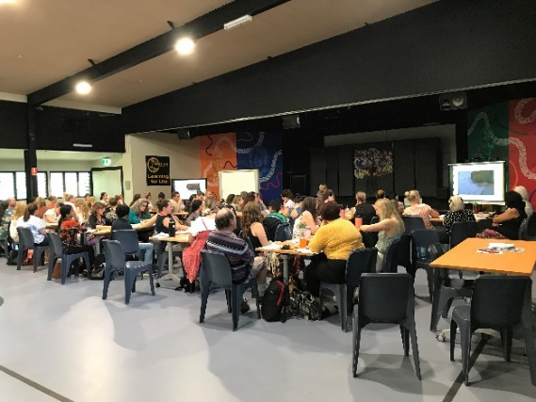
One recent decision was the Council’s approval of our Professional Learning day on Tuesday 6th April. The day was facilitated by Dr Misty Adoniou, an international consultant in Language and Literacy. Misty is an Associate Professor at the University of Canberra and was the lead writer for the national English as an Additional Language Teachers Resource which accompanies the Australian Curriculum. The opportunity was made possible through the generous sharing of the workshop by Leanyer Primary School. Our two schools have been working together since the beginning of the year to strengthen how we teach language and literacy. Malak Primary hosted the workshop in our assembly area and it was fantastic to see 70 teachers learning together so all our students can achieve greater success in their writing.

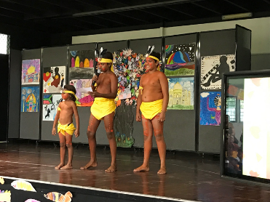
One of my biggest joy bubbles from Term 1 would have to be our all-day celebration of Harmony Day on Friday 19th March. Harmony Day occurs in March each year and includes 21 March, the International Day for the Elimination of Racial Discrimination. The ongoing theme of Harmony Week is 'everyone belongs'. Our celebration opened with three proud traditional owners, the Wesley family, offering the Welcome to Country. It was a beautiful moment.

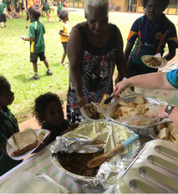
Thanks to a Multicultural grant, we were able to support families and staff to make and share food from their culture with the whole school. I admit to being nervous about having enough food – but I needn’t have worried! We had tables groaning with food from as a far away as Ireland, China, the Philippines, Mexico and as close as the Aussie sausage sizzle and kangaroo stew.

Our cultural concert, while small this year, showcased amazing dances and songs. Thank you to the organising committee for all the work to make the day possible and to all families and staff who contributed on the day.

As part of our ‘re-branding’ the amazing Malak School community, you will have seen some draft uniform designs in our last newsletter. Since then, one of our parents, Ms Rose Clape has stepped up to help us with her expertise in graphic design. Rose’s ideas have taken the design to another level! You can see her two designs below.

All staff students and School Council members have given us their vote and feedback and we are days away from finalising what will be the new school uniform for Malak Primary school. Exciting!
Option One: Option Two:
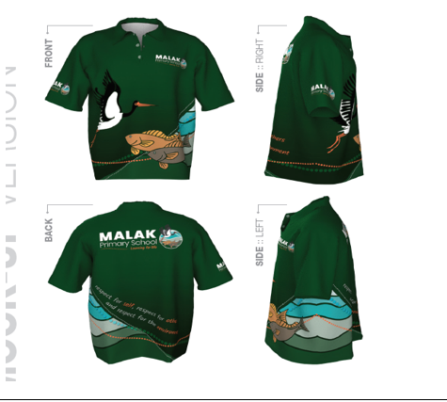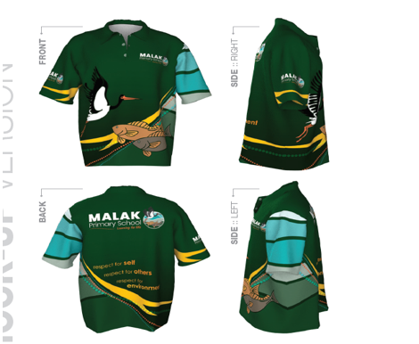
You are very welcome to send in any comments, preferences about the new designs – but be quick the approved design will go to the supplier in the next two weeks!

Have a great week’s holiday and please get in touch with any celebrations, concerns or ideas. As always, if you need to see us about a serious or private matter, please book a time so we can dedicate the time and attention you deserve – schools are busy places and I understand the frustration if no-one is available when you need to see us.

Lorraine Evans
Principal Malak Primary
Schools Plus Fellow
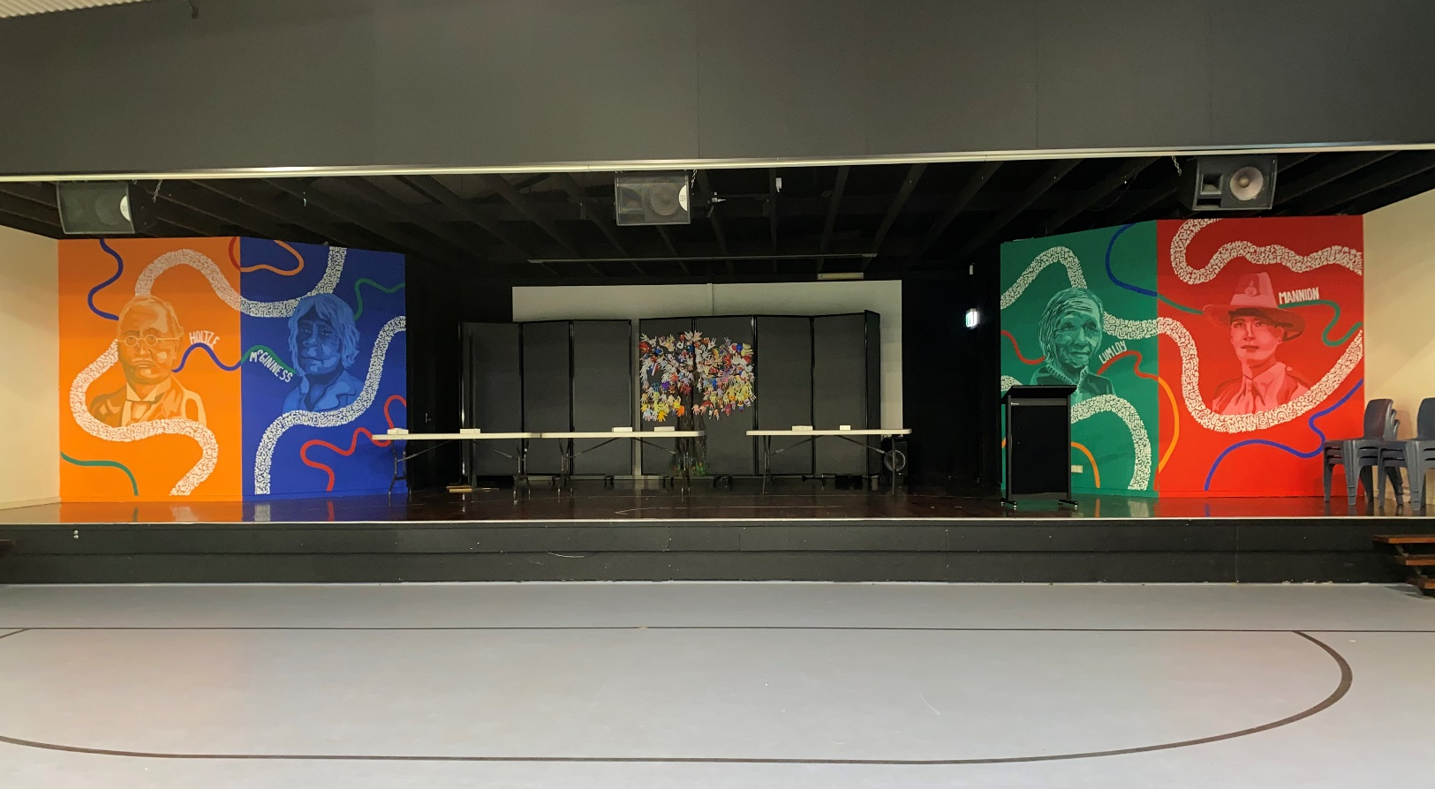

Celebrating our Sports House Champions
Holtze, McGinness, Lumloy and Mannion

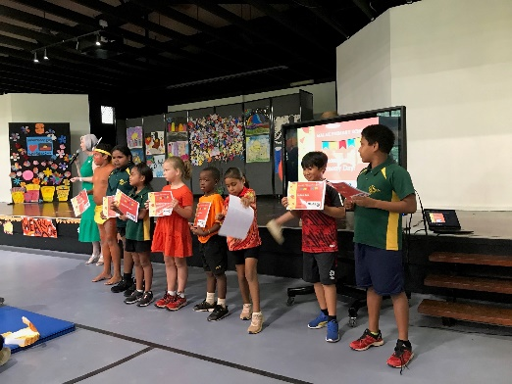
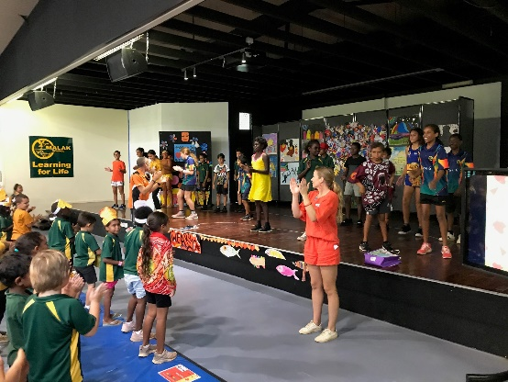
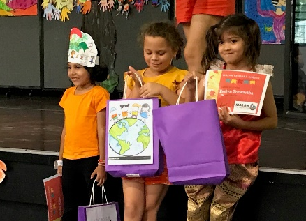

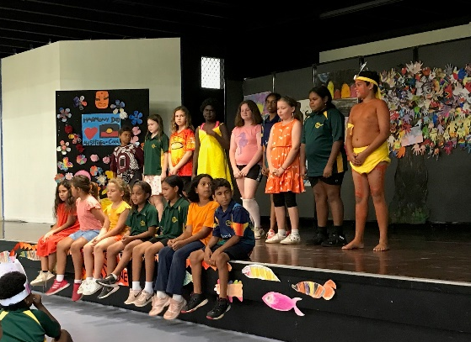
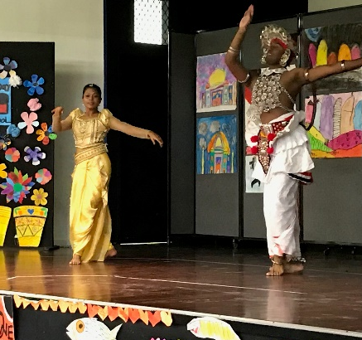
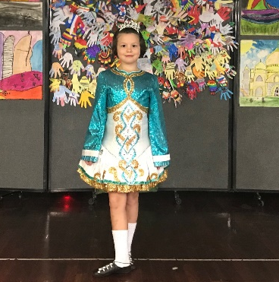

Harmony Day 2021

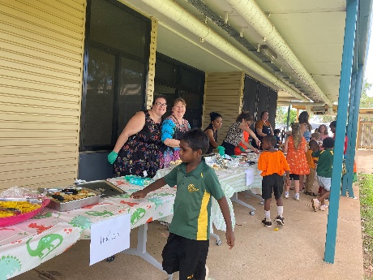
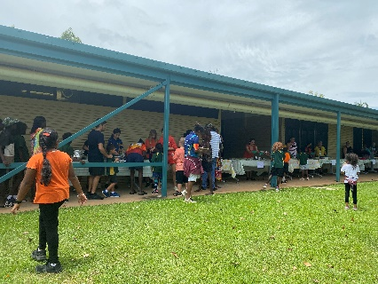
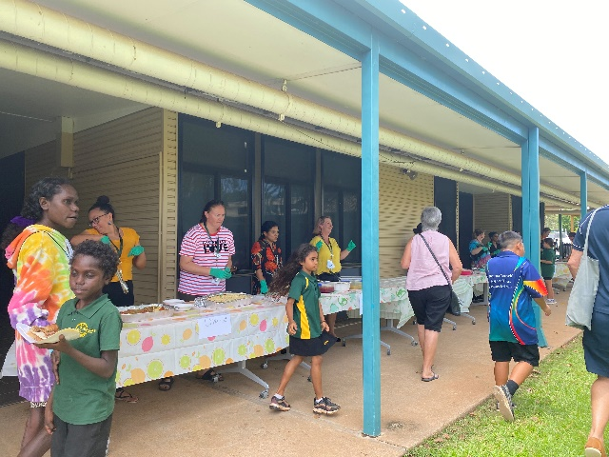

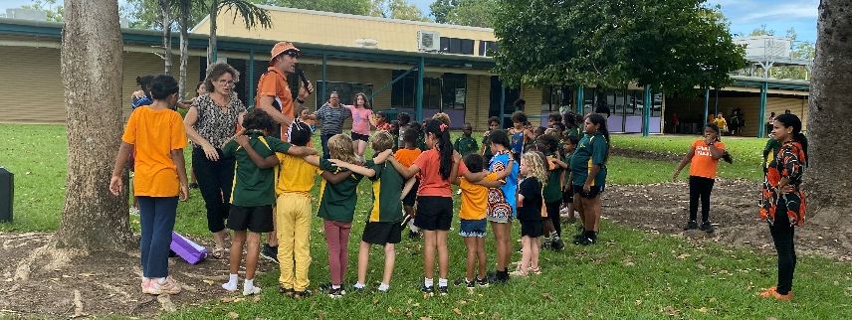

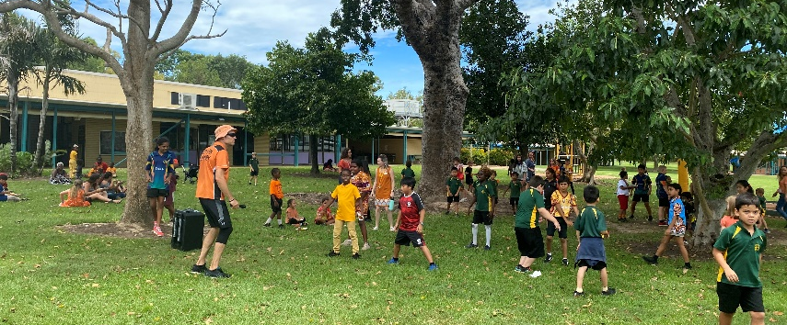
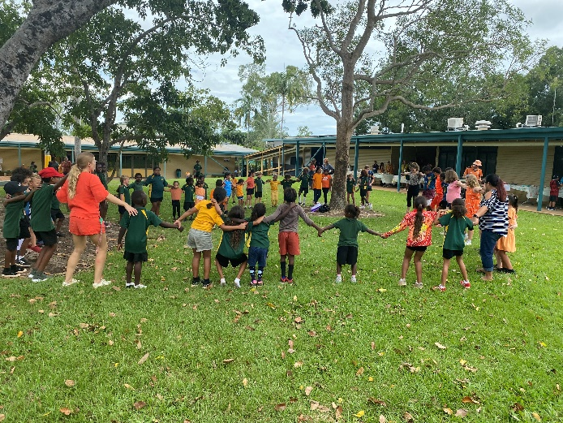

DATES TO REMEMBER

- Monday 19th April – Students return for Term 2

- Friday 23rd April – EELs Gala Day

- Thursday 17th June to 18th June – 3/4 Wildlife Park Camp

- Tuesday 24th August to 25th August – 5/6 Wildlife Park Camp



